Shopping Flow Testing
Introduction
This document contains the shopping flow test scenarios automated using Selenium, Cucumber BDD, and Java.
The purpose of these test cases is to verify that a user can search for a product -> add it to the cart -> proceed to checkout -> and successfully place an order.

Test Scenarios Covered
1. Buy Single Product End to End (@smoke)
Objective:
Verify that a user can successfully purchase a product from searching in catalog page to placing order.
Steps Covered:
- Open catalog page
- Search for a product
- Add first product to cart
- Verify cart item count
- Verify cart item count at badge
- Open cart
- Proceed to checkout
- Place order
- Verify order confirmation message
Expected Result:
Order should be placed successfully and confirmation message/ card should be displayed.

2. Cart Badge Validation (@smoke)
Objective:
Verify that the cart badge count is updated after adding a product.
Steps Covered:
- Search for a product
- Add product to cart
- Check cart badge count
Expected Result:
Cart badge should display correct number of items.
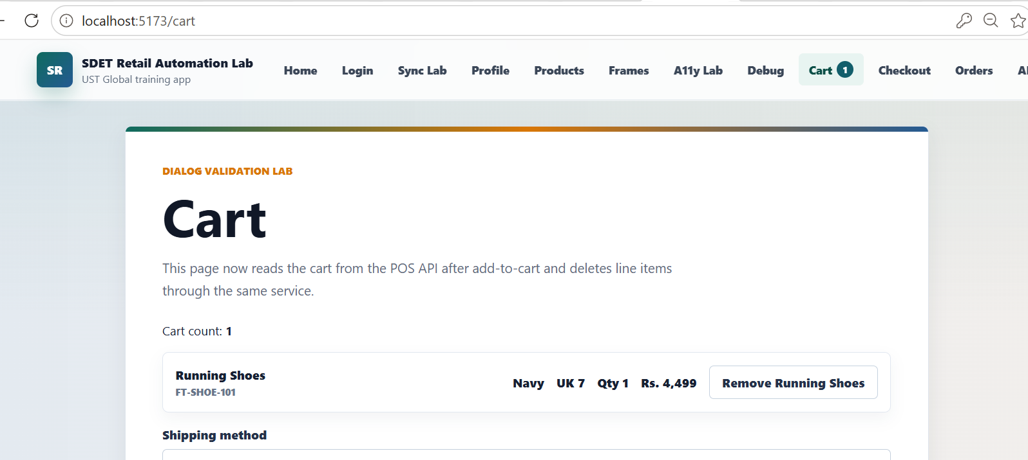

3. Buy Multiple Products Using Scenario Outline (@regression)
Objective:
Verify shopping flow for different products using Scenario Outline.
Products Tested:
- Headphones
- Lamp
Steps Covered:
- Search product
- Add product to cart
- Verify cart count
- Complete checkout
- Verify order confirmation
Expected Result:
Each product should be added successfully and order should be confirmed.
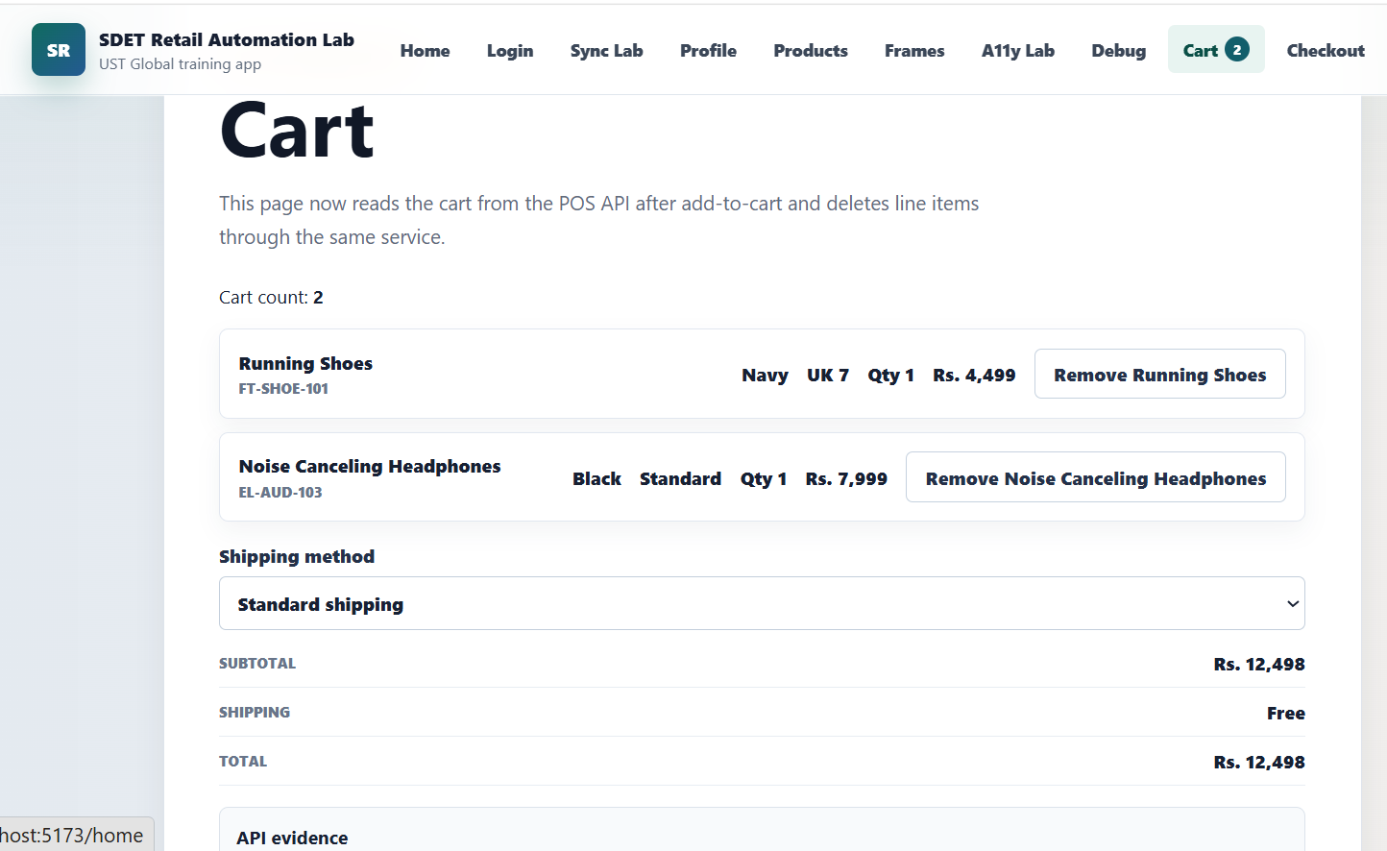

4. Verify Empty Cart (@exercise)
Objective:
Verify that a fresh cart does not contain any items.
Steps Covered:
- Open cart without adding products
Expected Result:
Cart should display 0 line items. 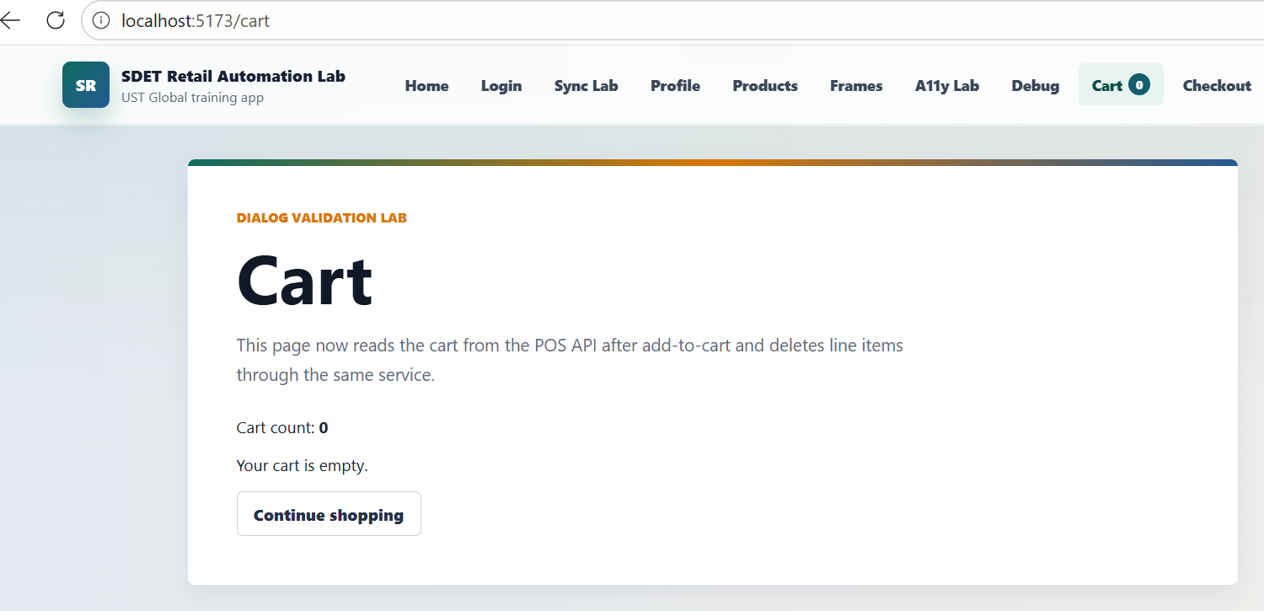

5. Negative Test Scenario (@negative)
Objective:
Verify failure handling and screenshot capture functionality.
Steps Covered:
- Add one item to cart
- Validate incorrect expected count intentionally
Expected Result:
Test should fail and screenshot should be captured by the allure and spark.

Framework Components Used
- Selenium
- Java
- Maven
- Cucumber BDD
- JUnit
- Page Object Model (POM)
Main Files Used:
- ShoppingSteps.java
- World.java
- Hooks.java
- CatalogPage.java
- ProductPage.java
- CartPage.java
- CheckoutPage.java

Conclusion
The shopping flow automation was successfully implemented using Selenium and Cucumber BDD. The framework covers positive, regression, and negative test scenarios. Screenshot capture on failure is also implemented .

